**Assignment 2**

**CS4186 Computer Vision and Image Processing**

**Name: Aryan Girish Kasliwal**

**SID: 55972222**

**Stereo images are slightly offset images which is caused by a technique called stereoscopic imaging. Both images are of the same object but are taken from minutely different angles. This difference in angle of capturing the pictures can be better understood as binocular vision. The small displacement between the pixel values in the images give us a good idea of spatial depth. The objects that are closer will have a larger displacement whereas objects that are far will observe lesser displacement in the two images. This brings us to the concept of disparity maps.**

**By definition, a disparity map is the apparent pixel difference between a pair of stereo images. To understand this better, it can also be called as a depth map. Below is an example of a disparity map given in the assignment where objects that are lighter shaded imply that they are closer to the camera while distant objects appear darker.**

In this assignment I have used python’s CV2 library to create disparity maps of the three pairs of stereo images given. CV2 has a function called StereoSGBM_create() which takes in a long list of parameters and creates a stereo object, which is then capable of computing the disparity maps for various images by calling its function stereo.compute(image_left, image_right). The parameters I have put in to my StereoSGBM_create() function are as follows:

The parameters used significantly affect the resulting disparity maps. If any of these values are changed, they would create different disparity maps with different PSNR values.

**minDisparities:** This is the minimum possible disparity value.

**numDisparities:** This is equal to maximum disparity - minimum disparity.

**blockSize:** Matched block size. Usually it is an odd number in the range 3-11.

**uniquenessRatio:** Percentage by which the best computed cost function beats the second-best cost function.

**P1 & P2:** The parameters controlling the disparity smoothness.

**Disp12MaxDiff:** Maximum allowed difference in pixel units in the left-right disparity check.

**preFilterCap:** The algorithm first computes x-derivative at each pixel and clips its value [-preFilterCap, preFilterCap] interval.

**speckleRange:** Maximum disparity variation within each connected component.

**speckleWindowSize:** Maximum size of smooth disparity regions to consider their noise speckles and invalidate.

**mode:** There are 4 modes “cv2.STEREO_SGBM_MODE_HH”, “cv2.STEREO_SGBM_MODE_SGBM”, “cv2.STEREO_SGBM_MODE_SGBM_3WAY”, “cv2.STEREO_SGBM_MODE_HH4”.

The above parameter values create the three disparity maps as required. My implementation first saves these three disparity maps inside “PSNR_Assignment2/PSNR_Python/pred” and then compiles and runs the given python file “psnr_cal.py”. This saves the three disparity maps as well as computes the respective PSNR values.

# Art

The two given stereo images for art are shown below.

Running the function with parameter values as above gives me a PSNR value of 12.0718. The disparity map hence produced is as below.

The disparity map on the left is given and the one on the right is the one produced by my implementation. Though its not as clear as the given one, the right map still accurately shows the outlines of the objects in the images and gives a decent estimate of the depth of the objects as well as background.

# Dolls

The two given stereo images for dolls are shown below.

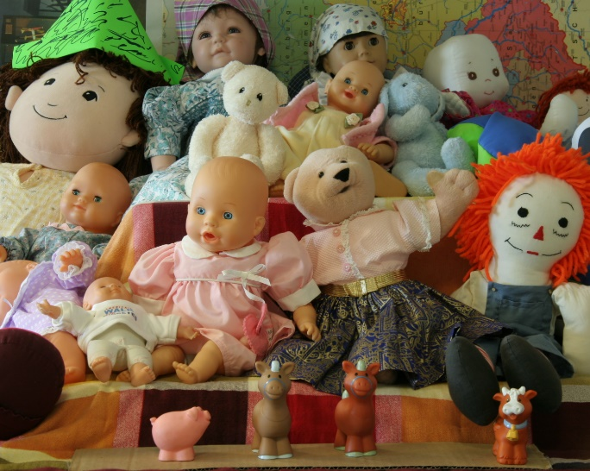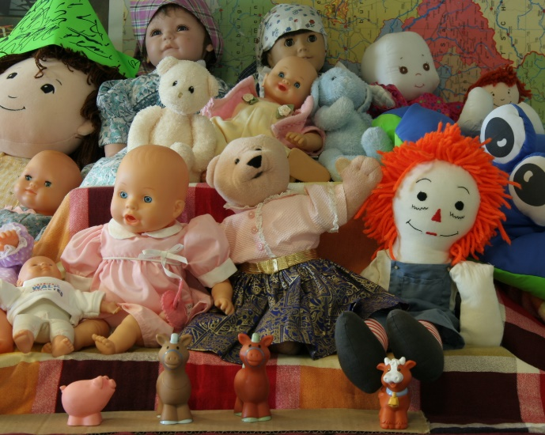

Running the function with parameter values as above gives me a PSNR value of 10.6817. The disparity map hence produced is as below.

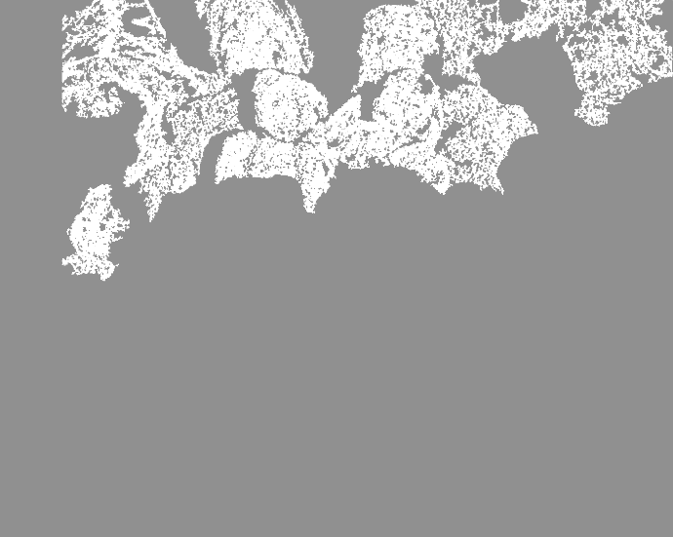

The disparity map on the left is given and the one on the right is the one produced by my implementation. Though it’s not as clear as the given one, the right map still accurately shows the outlines of the objects in the images and gives a decent estimate of the depth of the objects as well as background.

# Reindeer

The two given stereo images for dolls are shown below.

Running the function with parameter values as above gives me a PSNR value of 11.2446. The disparity map hence produced is as below.

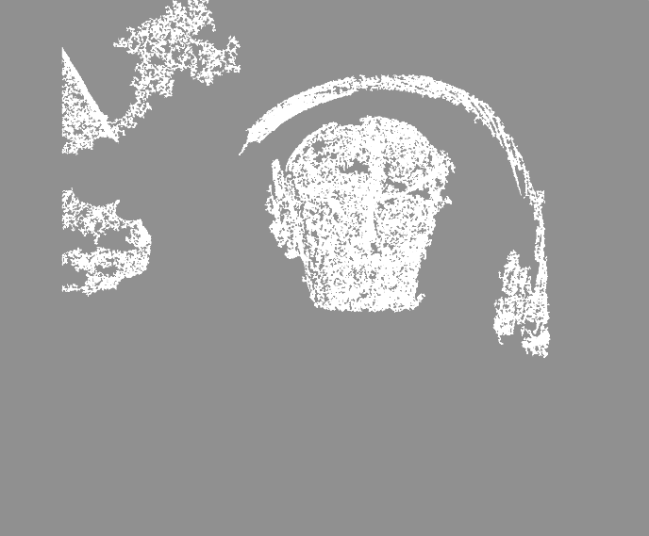

The disparity map on the left is given and the one on the right is the one produced by my implementation. Though it’s not as clear as the given one, the right map still accurately shows the outlines of the objects in the images and gives a decent estimate of the depth of the objects as well as background.